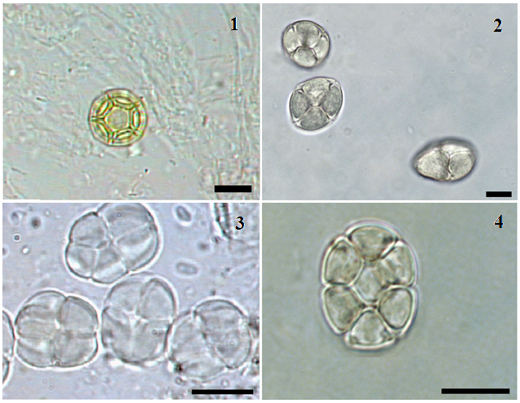
Figure S1 – Main pollinic types found in the honey samples. 1- Alternanthera sp.; 2 - Mimosa verrucosa; 3 - Mimosa caesalpiniaefolia; 4 - Piptadenia gonoacantha; Black bar=10 μm.

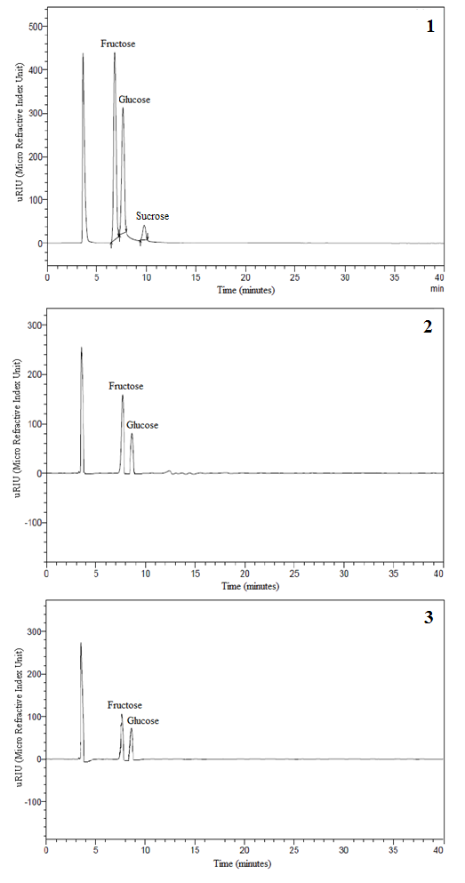
Figure S2 – Chromatograms of carbohydrates for the two types of honey under study:
1 – Sugar standards; 2 - Apis mellifera honey sugars; 3 - Melipona subnitida honey sugars.

