International Workshop on Honey Sensory Analysis
Meeting of the IHC Sensory working group

TENERIFE 2013, May 13th/14th

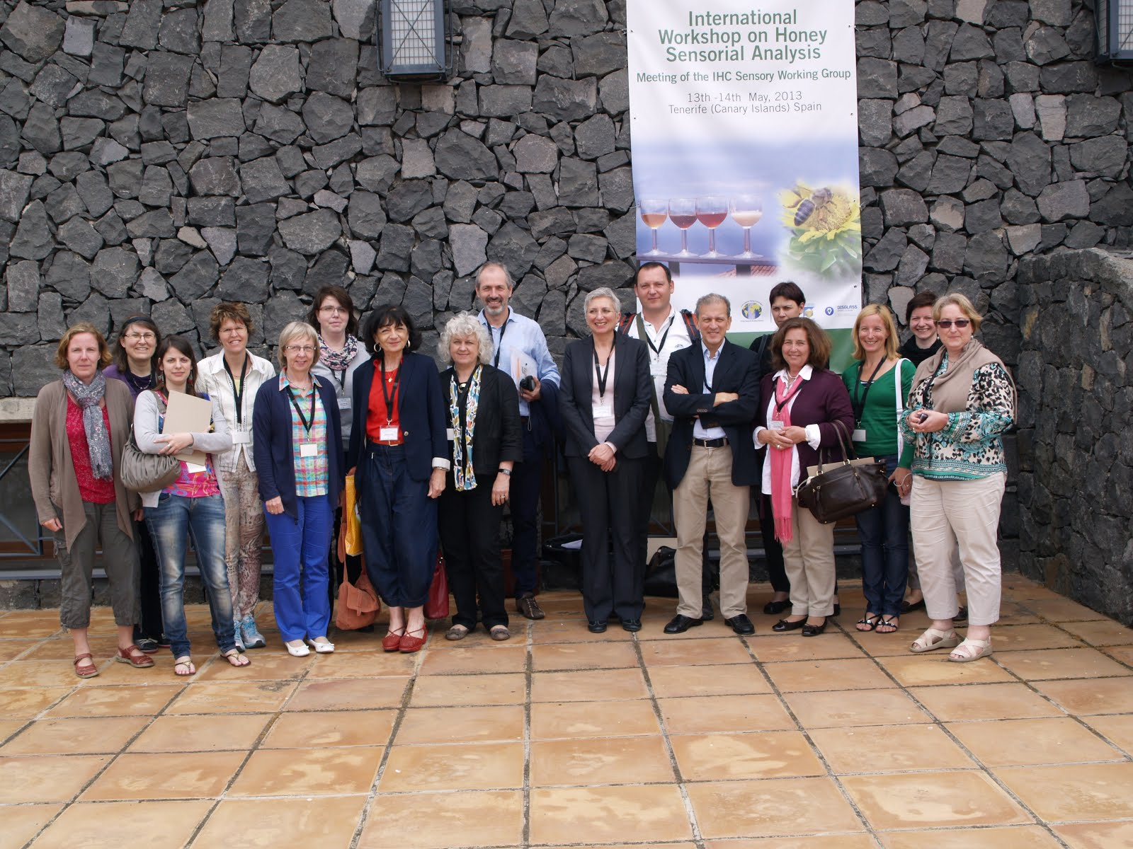

On May 13th and 14th a workshop of the sensory working group took place in Tenerife, Spain in la Casa de la Miel, directed by Antonio Bentabol who had organized the event. The aim of the workshop was to share experiences and continued progress in the standardization of working methods applicable in the sensory control of honey, expecially to:

- update and validate our shared “aroma wheel”;
- advance in the definition of a common method of work and vocabulary to be used in sensory honey analysis.

The workshop was attended by:

The workshop was attended by:
- Katja Bohm, Intertek Food Services GmbH, Germany;
- Mojca Korosec, Dep. Food Science & Techonolgy, Biotechnical Faculty, University of Ljubljana, Slovenia;
- Jasna Bertoncelj, Dep. Food Science & Techonolgy, Biotechnical Faculty, University of Ljubljana, Slovenia;
- Joana Godinho, National Institut of Biological Resources (INBR) - Posto Apicola (National Beekeeping Center), Portugal;
- Katharina Bieri, Biologisches Institut für Pollenanalyse, Swiss
- Gian Luigi Marcazzan, CRA-API, Italy;
- Lucia Piana, Piana Ricerca e Consulenza srl, Italy;
- Antonio Bentabol, CASA de la Miel, Spain;
- Drazen Lusic, Department of Environmental Health, Faculty of Medicine, University of Rijeka, Croatia;
- Bade-Wegner, Quality Services International GmbH, Germany;
- Gudrun Beckh, Quality Services International GmbH, Germany;
- Ana Pascual Maté, University of Burgos. Department of Food Science and Technology, Spain;
- Hana Vinsova, Bee Research Institute, Czech Republic;
- Christina Kast, Agroscope Liebefeld Posieux, Swiss;
- Monique Morlot, Laboratoire Famille Michaud Apiculteurs, France;
- Susanne Hanewinkel-Meshkini, CVUA - Ostwestfalen Lippe, Germany;
- Carine Massaux, CARI asbl, Belgium.

At the beginning of the meeting we focused our attention on defining a shared “aroma wheel” starting from the one published in Apidologie 2004 that has undergone changes over time.
We proceeded step by step taking into consideration the single families of the wheel. After an overview and discussion of the wheel, families and subfamilies were established. In annex 1 the proposal before discussion and results after discussion are reported. After that, the participants were asked to smell different kinds of odours from special containers and to classify the perceived odours in accordance with the previous discussion. In this way the assessor could test if the perceived sensation matched with their idea of the family and subfamily. A final confirmation of which family and subfamily to adopt was made at each step following a further post-test discussion.

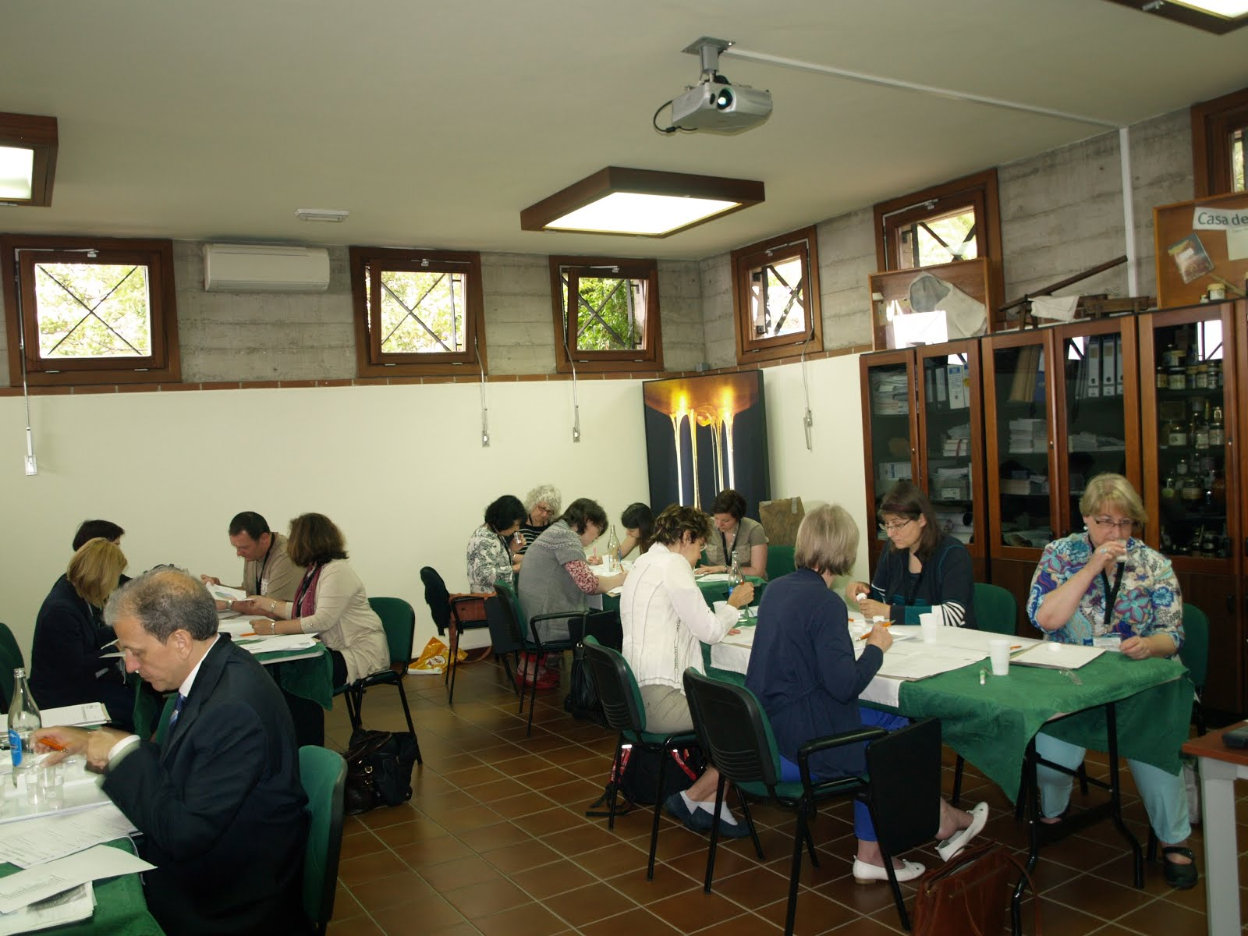

For the tests different kind of products were used, most of them specifically produced for smelling games (Sentosphère http://www.sentosphere.fr/ : Sentosphère 1: Parfumaster Les odeurs de la maison de ma grand-mère; Sentosphère 2: Parfumaster Les odeur du jardin de mon grand-père; Sentosphère 3: Parfumaster Les odeurs du verger-ptager, Sentosphère 4: Le loto des odeurs, Sentosphère 5: Bacchanales, Sentosphère 6: La route des epices) or as alimentary aroma (from Etol d.d. - http://www.etol.si/index.php/sitemap). Lists of commercial references in annex 2 are reported.

The study took over one and a half days but in the end the group reached an agreement on the final “composition” of the wheel.

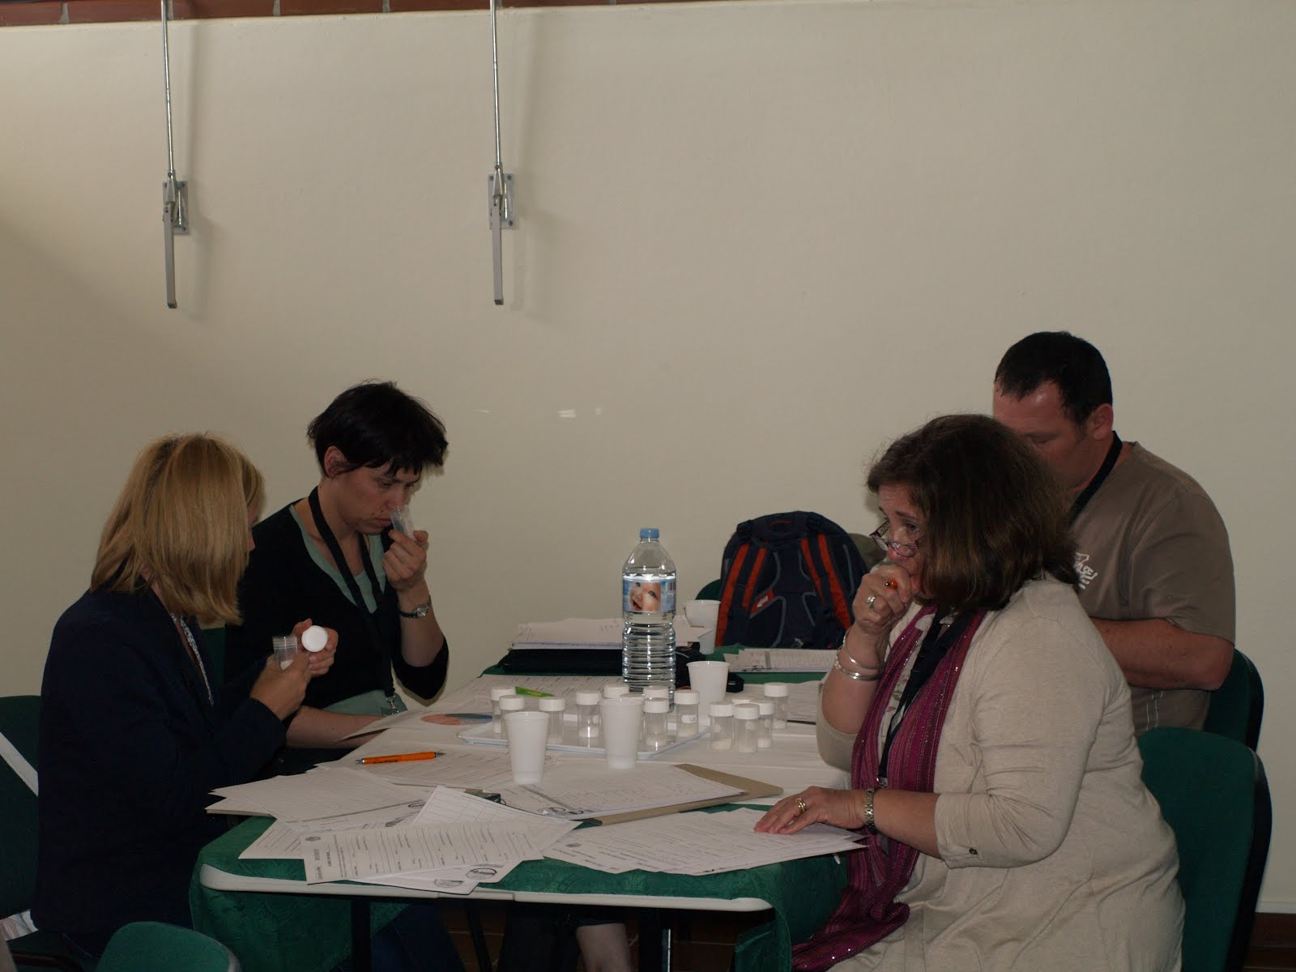

These decisions were made on the basis of the broad experience of the experts on honey sensory evaluation. In annex 3 the list of references tested and the results are reported.

In order to do a kind of validation of the results of the work and to chose the most appropriate reference for each subfamily, a classification test was performed. Each assessor was given unknown products representing the subfamilies and each subfamily was represented by more than one reference.

The assessors generally classified most of the references similarly but some classifications were spread over more than one family or subfamily. As a result, a small number of references remained unclassified. The results of this step are summarized in annex 4 and 5.

The reasons for this may depend on more than one factor: the references were not appropriate because they were old or unrepresentative of the declared origin (badly manufactured); the experience, education and culture of the assessors are different so that they are not familiar with certain odours so they have difficulty classifying; the assessors are not trained well enough for the specific purpose.

Annex 6 reports a final non exhaustive list of references that we proposed in accordance with the results of the workshop.

On the basis of these considerations further work needs to be done in order to complete the set of references. The symposium of Apimondia would be a good place to summarize the work done and to continue it.

Honey sensory evaluations using the sensory profile sheet that was presented at last year’s II International Symposium on Bee Products in Braganza was performed on the last day.

Honeys were assessed by the international group of experts together with the panel from “Casa de la Miel”. Eleven honeys were evaluated, four honey types from Italy, six from Tenerife and one from Argentina:

Retama del Teide - Broom - Spartocytisus supranubius
Hinojo - Fennel - Foeniculum vulgare
Barrilla - Crystalline iceplant - Mesembryanthemum crystallinum
Poleo - Bystropogon origanifolius
Pitera – Agave - Agave americana
Aguacate - Avocado tree - Persea americana
Lime – Tilia platyphyllos
Acacia - Robinia pseudoacacia
Citrus – Citrus spp.
Ailanto - Ailanthus altissima
Argentinian honey

The form represents the practical application of the use of the aroma wheel and the vocabulary we have developed. In this way it was possible to experiment with the new definitions.

The tasting was carried out just as an example of its application in honey evaluation and of the construction of the honey sensory profile.

Before the evaluation the form was updated following the final decision of the working group.

The profiles obtained are visible in the attached file.
